Header

QA14: If user is viewing pages as doer and now want to switch as poster. He clicks on Poster tab then which page would be visible to him. Likewise if he switches from Poster to Doer than which page would be displayed.

QA15: What will be the default role of user just after login?

QA16: Will user name be displayed somewhere after login?

QA17: Will user choose username. Which login options would be allowed to login user (username, single email, single phone, multiple emails, multiple phones or any other)?

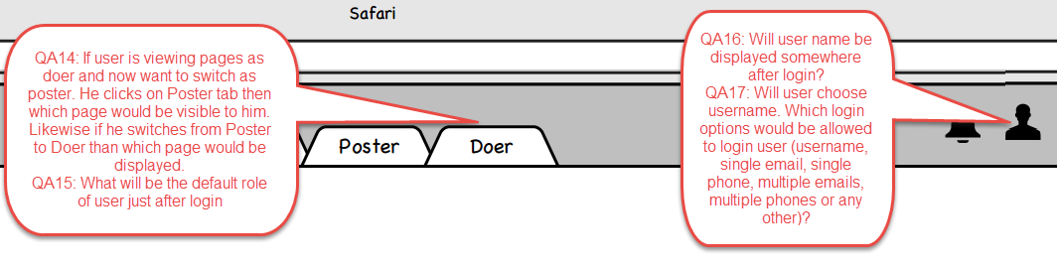

---------------------------------------------------------------------------------------------------------------------------------

Proposal list

QA18: How is Average Experience is calculated.

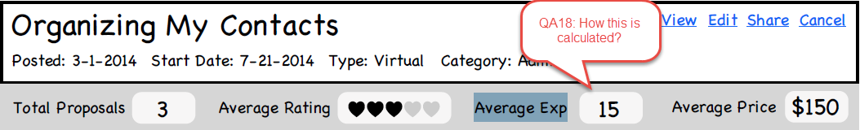

---------------------------------------------------------------------------------------------------------------------------------

QA19:  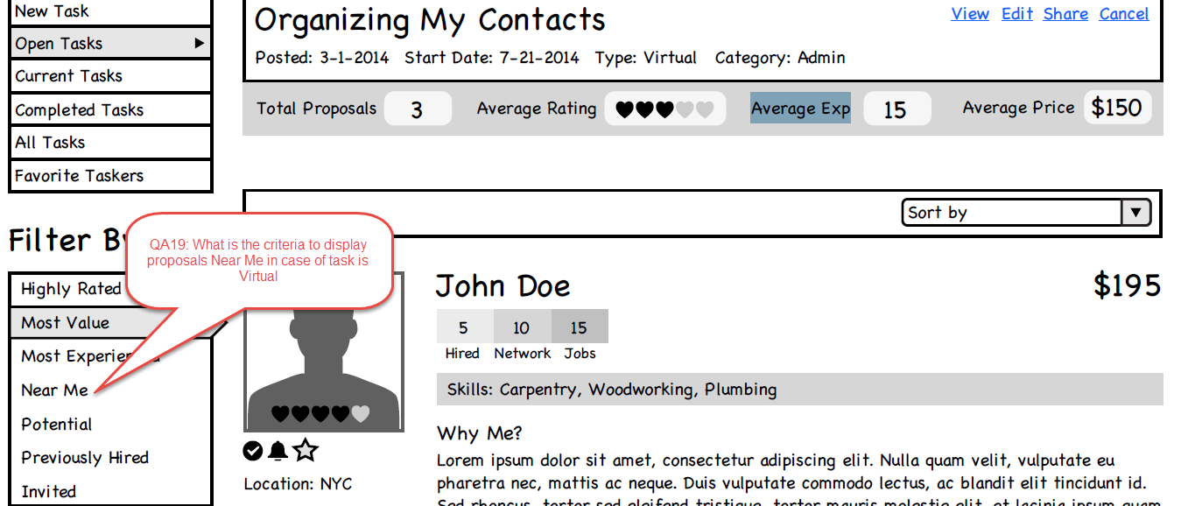

QA20: Is this the total of Hired and Network jobs?

QA21: Will jobs done outside/external to site which are added in portfolio be counted here?

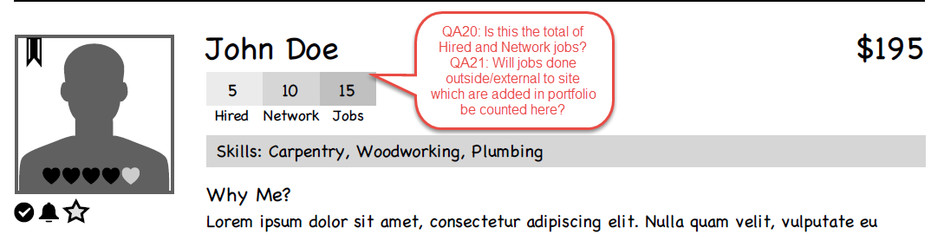

---------------------------------------------------------------------------------------------------------------------------------

QA22: Clicking here will open proposal detail page in separate tab?

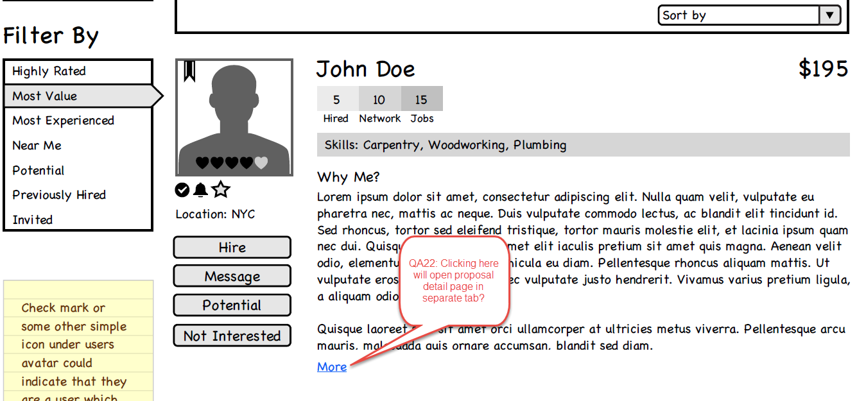

---------------------------------------------------------------------------------------------------------------------------------

QA23: This page is proposal detail page. Clicking here will open project detail page is separate tab?

QA24: What is the purpose of Edit Project here? I assume we are not allowing edit project once someone has bid on it.

QA25: I assume this is Average rating of doers who sent proposals for this project.

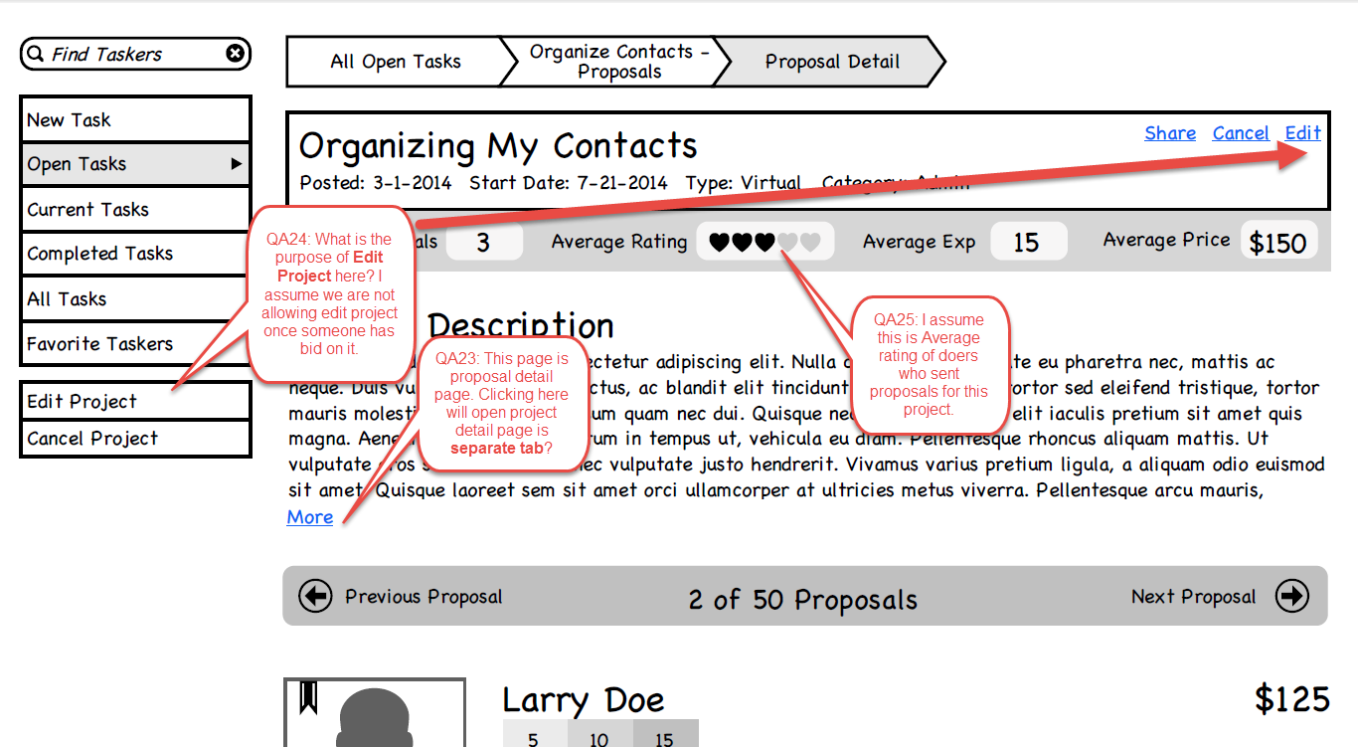

---------------------------------------------------------------------------------------------------------------------------------

QA26: I assume you asked to keep only one total. Please confirm the difference between these two or whether to keep both or which should be eliminated.

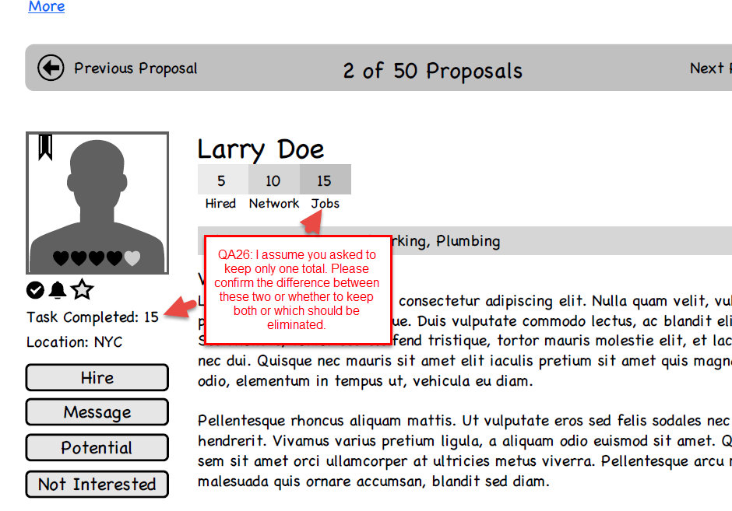

---------------------------------------------------------------------------------------------------------------------------------

QA27: Is the start date same as project award date?

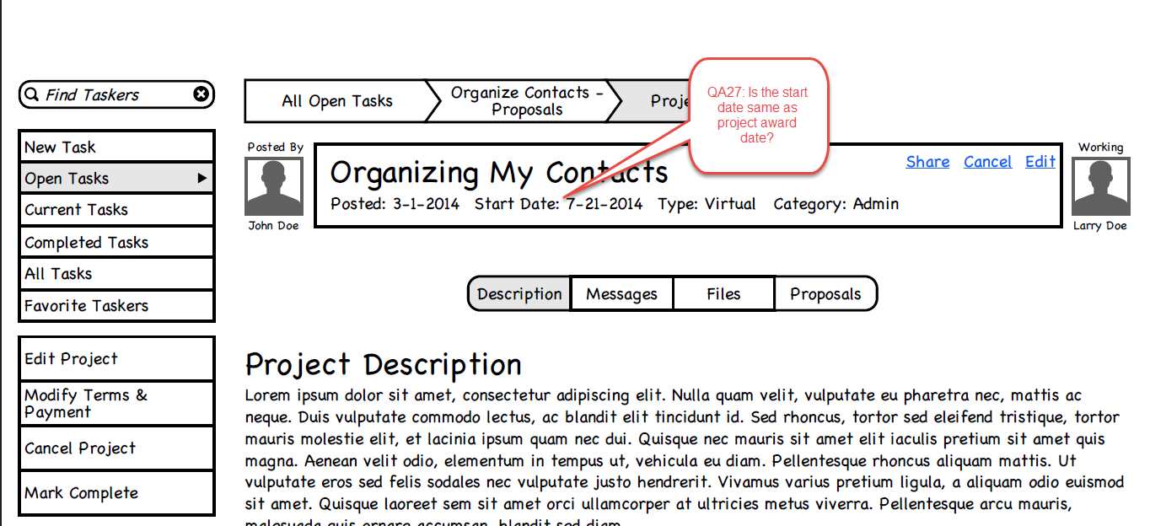

---------------------------------------------------------------------------------------------------------------------------------

QA28: Which file formats are allowed when doer submits proposal? Can doer upload audio/video file as proposal?

---------------------------------------------------------------------------------------------------------------------------------

QA29: Will this mark most recent project as unread?

QA30: Will there only most recent message be  displayed here or poster can see complete communication of this project on this page. We can place inbox detail page link to view full communication for this project. Please elaborate the flow.

QA31: Can we use progress bar to display time left or time elapsed for the project completion as an extra UI option?

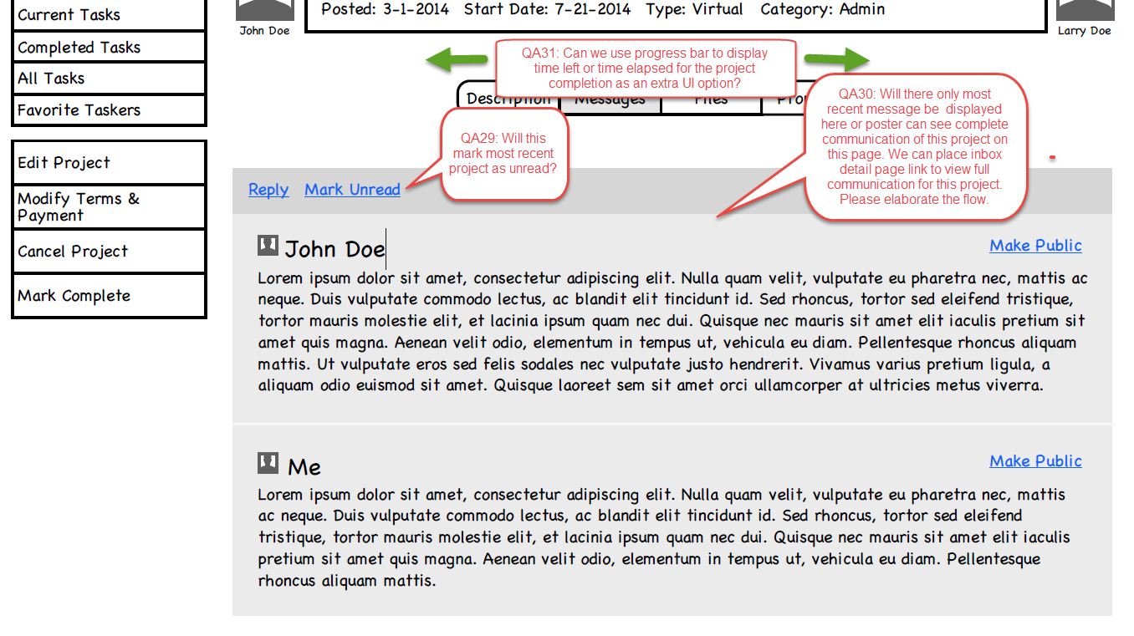

---------------------------------------------------------------------------------------------------------------------------------

---------------------------------------------------------------------------------------------------------------------------------

Create Task

We added an option to save the project details and publish it later by giving two buttons Save and Publish. When poster clicks on Publish current date becomes project post date.

Is the start date same as project award date?

Can price range be unspecified by the poster?

Is the Estimated cost calculated by considering minimum value from price range?

Can user use someone else project as template?

Are we managing space storage for each user?

Which file formats are allowed to upload as project detail?

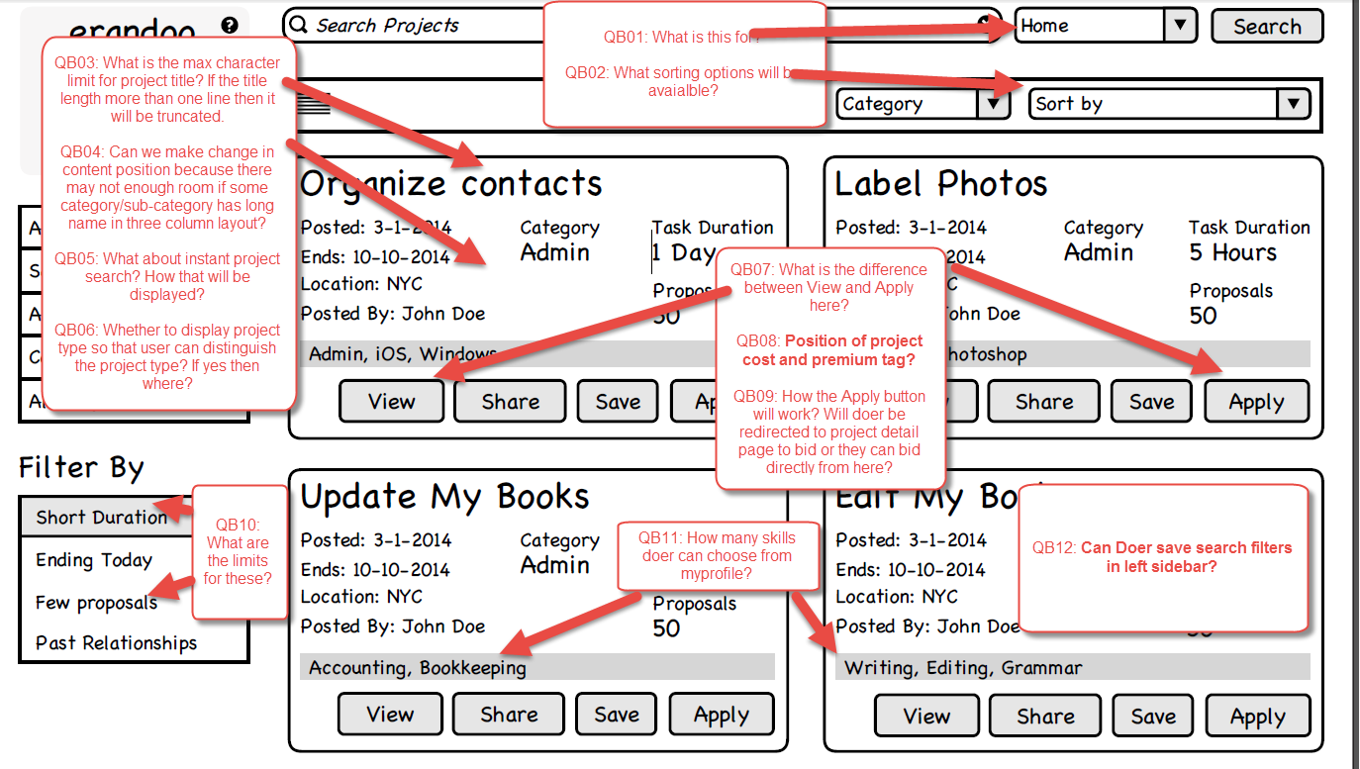

Great questions as always! I love the questions.

Answers:

**QB01**: This selection allows the user who is searching to change the ‘location’ they are searching for. For instance, if they are at their office, they might be searching for projects that are near their home. Maybe they are looking for a delivery project that is between their regular work and their home so they can make the drop-off on the way home after work. There are endless reasons why a user would want to search for projects in a different location.

The locations will be determined by zip codes, but the user will name the locations themselves on their account settings.  A user will be able to have several locations stored for their account, and this search box lets them toggle between them. This is a very powerful feature because users might live in a place that is far from their work, but could be searching for projects near their home. Or, users might be searching for a third party (for instance, maybe they are looking for a Doer that can help their elderly parents, who live in a different city).

**QB02**: The default search results, before sorting or filtering will be the projects that are the most relevant for the searcher, based on skills and preferences from their profile and previous tasks they have already participated in (NOTE: I know you are far more expert at predictive results that I am, so I won’t attempt to describe them better than you already know).

When the searcher wants to sort the results, here are the choices:

|  |  |
| --- | --- |
| Sort | Description |
| Newest Posting | Sort the projects with most recently posted at the top of the results |
| Oldest Posting | Sort the projects with the oldest projects at the top of the results. These will be projects that are still active (not awarded) but has been posted in the most lengthy period of time in the past. |
| Longest Duration | Sort the projects with the greatest estimated duration at the top or the results. |
| Shortest Duration | Sort the projects with the shortest estimated duration at the top or the results. |
| Highest Earnings | Sort the projects with the highest estimated Price at the top or the results. |
| Lowest Earnings | Sort the projects with the lowest estimated Price at the top or the results. |

**QB03**: Let’s maximize it. Based on the space available on the wireframe, it looks like 27 will fit. Will that many characters fit without skewing the alignment?

**Matthew:** The exact size and all will be determined when we do the design because we don't know the exact font etc as of yet. But I would definitely say keep it in one line and simply have an elipses to indicate there is a longer title there.

**QB04**: When the search results are in list view, any length of name should fit. What if when they are in card-view (like the screenshot you sent), we use the icon for the category instead of the name? The icon can be scaled down to fit without altering the shape and alignment of the boxes.

**Matthew:** Definitely something we may play with to see what looks right in the design. If we use just the title I think  it would just have an ellipsis if it wound up being a long title. It probably will be fine in the actual design though as our usage of fonts and sizes will be different.

**QB05**: There will never be a search for an instant project. Remember, instant project works differently than a virtual or an in-person project. The Doer for an instant project is logged-in waiting and the poster chooses the Doer. The instant project does not have Doers searching for projects -- the Poster will select the instant Doer from the ‘create-an-instant-project’ screen. There will be no instant tasks to search through.

**Matthew:** A User can search for anything relating to a Virtual or In Person project. It wouldn't just be the title but also information and keywords they placed in the description. Possibly skills that a user requested etc.

**QB06**: The only choices for project type will be between Virtual Project and In-Person Project since we have already established that there will be no search results for Instant Project. The way we will distinguish between Virtual and In-Person will be with the field named “location”. The location will either display the market name (City/State/Province and country from their account) or the location will say “anywhere” if it is a virtual Project.

**QB07**: View will take you to the project detail page. Apply here will pop-up the bid proposal screen (like we are doing on the project detail) – it will pop-up over this page instead of over the project detail – quicker for the user!

**Matthew:** Really quick! A good example of this is to checkout gmail and click compose. What's great about this is the user can reference information on a project page and continue to look

**QB08**: Good catch. Can you put the estimated cost under the category? Is there room there without skewing the alignment? **Will it fit?** As for premium tag, let’s put a medallion (badge, icon, whatever) in the upper right and corner. We will have a designer make this medallion for us in the future, but for now, here is a mock-up medallion you can use as a place-holder.

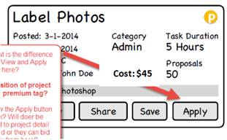

**Matthew:** My thought was that premium projects would be differentiated by a slight variation in the contrast or color of that card. Maybe with a tiny premium tag in one of the corners like brad has shown here. I think both actually would be good and the gold/yellow color may be something that works in the actual site when we get to that. For the price I think Brad chose a good spot. It's either there or we move category down and put estimate in it's place.

**QB09**: We are already doing the bid process as a pop-up on the detail page. That means we can use the same pop-up on this page to have them ‘quick apply’. Just pop the pop-up on this page instead of going to the detail page.

**Matthew:** Yep. This bid window could slide up from almost anywhere, which was one of the reasons for making it 'portable' and not an individual page.

**QB10**: Let’s give ranges of choices. Like this:

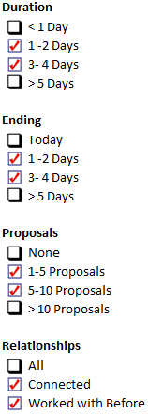

**QB11**: Basic member can choose 6 skills. Premium member can choose 12 skills.

**QB12**: Great Question. I think no. The filters should work like the filters on Amazon or on Ebay. They are easy to use filters. The users should have to put new filters in each time they create a search. I think their needs might change every time they search, so we shouldn’t keep their life simple by letting them start with fresh filters each time.

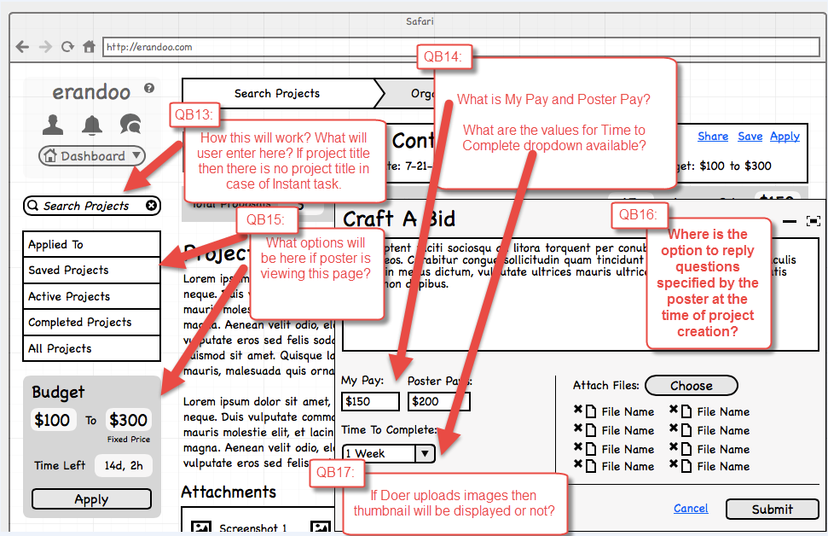

**Matthew:** Saved filters would be a bit much, at least for now I think. I feel we should keep the filters as simple as possible, not too many, just a few. Because of this there shouldn't be a complex filter a user has to setup and needs to save.

Also, let’s be sure to leave the possibility for expanding this list of filters at a future date as we learn more about how our customer uses this platform.

**QB13**: They will use key words to find other projects. This search box takes them to the search results page with the keywords they have chosen.

**Matthew:** This works the same as the search box on the main search page, it's just a quick way for the user to quickly put in their search and be taken directly to the search results page.

**QB14**: My pay is the amount that I am bidding – it is how much money I expect to earn. The poster Pays is the amount that the client will receive. Poster Pay is the amount the Doer will earn plus the fee – it is the amount that will be charged to the poster’s credit card. The website will populate one or the other, based on the input. It will know what the %rate is for the Doer and will calculate accordingly. It will work exactly like the same function on elance. Here is a screenshot of elance:

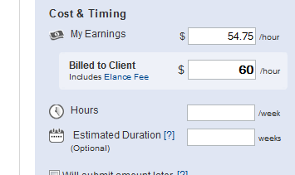

**QB15**: Great Question! If the poster is viewing, then the choices will be very similar to the choices for the Doer, but tailored for a person who have posted projects.

Like this:

|  |  |
| --- | --- |
| Selection | Description |
| Bid Proposals | The bids that have been made for this project. |
| Active Projects | Projects that I have active now. |
| Completed Projects | Projects from the past that are completed. |
| All Projects | A listing of all projects I have been involved with. |

There will be no action box for applying. Instead, there will be a box for editing this project (if there have been no bids posted yet).

**QB16**: Great catch! The questions need to be added, below the text input box.

Here is a crude mock-up of where the questions could go.

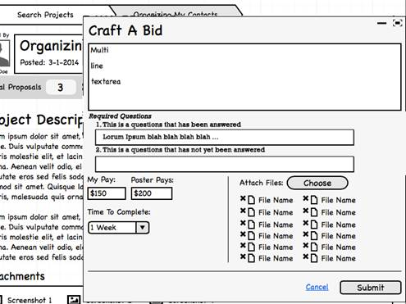

**Matthew:** This window will probably have to scroll if it turns out there are quite a few questions that we want a bidder to answer.

**QB17**: The icon that shows the uploaded file is very small. Let’s not have this icon be a thumbnail. Instead I should be a logo that shows the file type. These logos can be similar to the way Windows shows files:



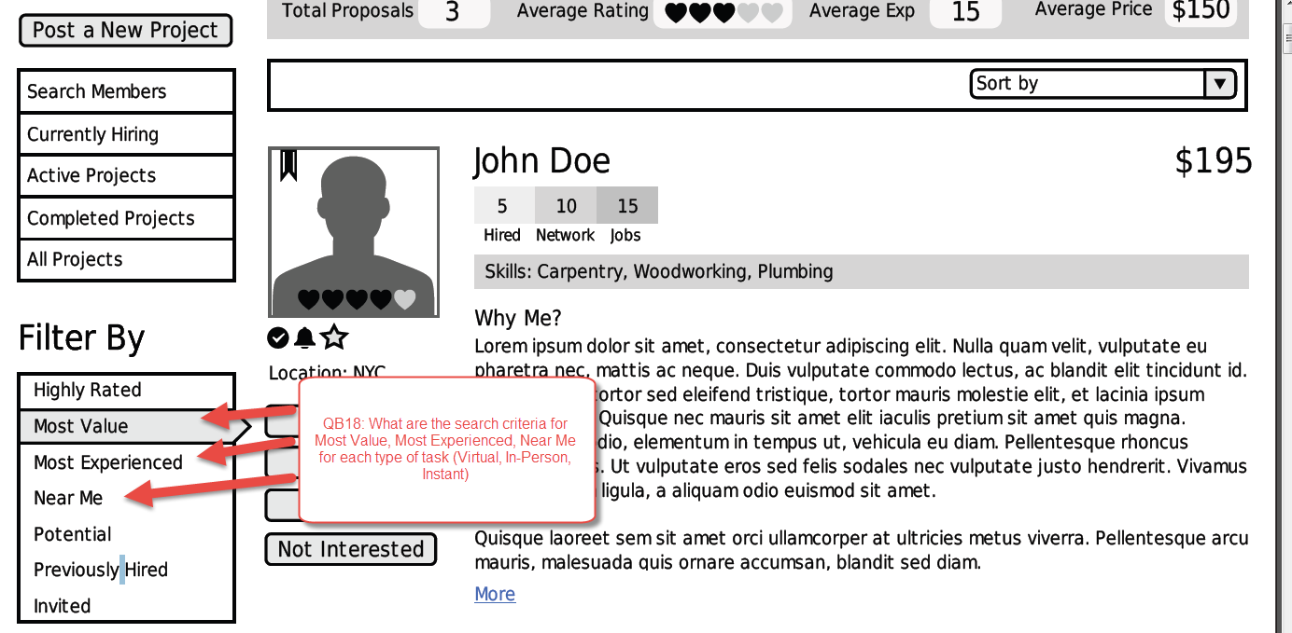

**QB18**: Search/Filter Criteria:

•         Most value will be: Doers who have the most matching skills compared to having bid the lowest price. In other words, these users are great value because their skills match the most, but their bid price is low. I am hoping you can create some sort of quotient that measures and displays this kind of result.

•         Most Experienced will be: Doers who have the most number of projects completed

•         Near me will be: Doers with the closest zip codes – if they are in the same zip code, it will be users who’s address is physically the closest. This will be the same for virtual and In-person tasks. There will be no search criteria for Instant tasks so there is no need to consider this type of task for the results.

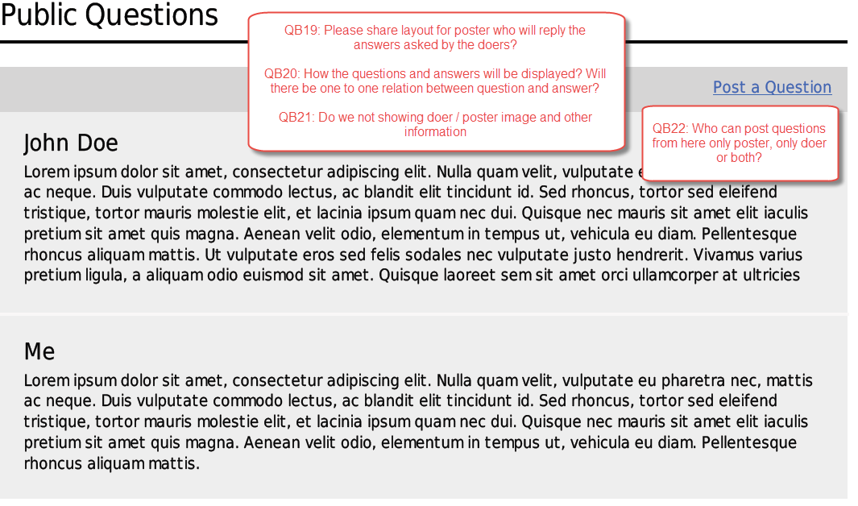  
  
**QB19**: It will look just like a message thread in message central. There will be a text link (or check box) that allows them to make the reply public.

**QB20**: The question and answer should be displayed in a box. The question and the corresponding answer should be shaded the same color to group them in readers minds.

**QB21**: No poster image, no other information. Just the question and the answer. In this context, it doesn’t matter who asked – it is now public information that is part of the posting.

**QB22**: The Doer asks a question. The Poster answers the question. The poster decides if this should be a public question or if the reply should stay private. This will work like eBay’s questions. The purpose is for a poster to make a question/answer public because it is a good question that will benefit everyone – and it saves the poster from answering the same questions 20 times for 20 bids because it is something obvious that he maybe should have put in the posting. The poster can decide to answer all of the questions privately or can toggle every question to be public if they choose.

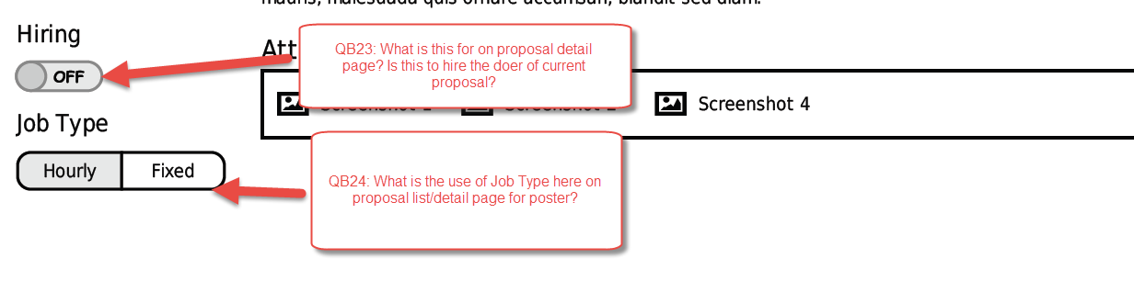  
Answers:

**QB23:** This option toggles the project as still hiring or no longer hiring. This is the mechanism that allows a Poster to hire more than one individual. As long as this option is “ON”, the proposals will remain active and the Poster will be able to hire more Doers for this project – and the project will remain visible on the search results for projects Doers can bid on. As soon as the option is turned “OFF”, the project will no longer be visible for Doers in the search results and no more proposals can be awarded by the Poster.

*For some context to help with understanding –* I have used this same feature on elance before. I created a new project and then hired several people for the same thing. I was conducting surveys for market research. The elancers did not work together and they did not know there were others doing the same project; but I was able to keep it “open” and continue hiring new elancers for the same project over and over until I was satisfied. Then I closed the project. Closing the project did not complete their work nor release the funds, all it did was make it so that I could no longer hire and I would no longer receive bid proposals.

Once the option is turned “off”, it will NOT be able to be turned on again. The project is ‘closed’ to new hiring. Once they turn it off, if they want to hire more, they have to create a new project (but they will be able to use this project as a template if they choose because it is one of their past projects).

**QB24:** This toggle allows the Poster or Doer to change the project from fixed price to Hourly.  The Poster and the Doer must both agree to the change in terms. When one toggles this selection, a message will go to the other to agree to this change and the new terms (the new hourly rate).

This will work like elance. Here is a screenshot of what the control looks like on elance:

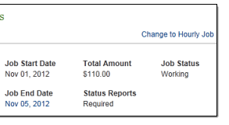

Virendra: How this will impact when project gets closed and display of project budget on various pages because there might have some payment is already done? Switching from one mode to other will change the project budget.

Brad: The DOER will apply the hourly rate to the hours already completed to be paid for work already completed.

For instance, a new project started on a Wednesday as a fixed price for $300. On Saturday, they agree to change this to an hourly task for $10 per hour. When the project is complete, or the following Wednesday when they submit their weekly invoice, the DOER will bill $10 an hour for the work they did on Wednesday, Thursday, Friday and Saturday (the days before the project changed from Fixed to Hourly).

# Proposal Detail Poster

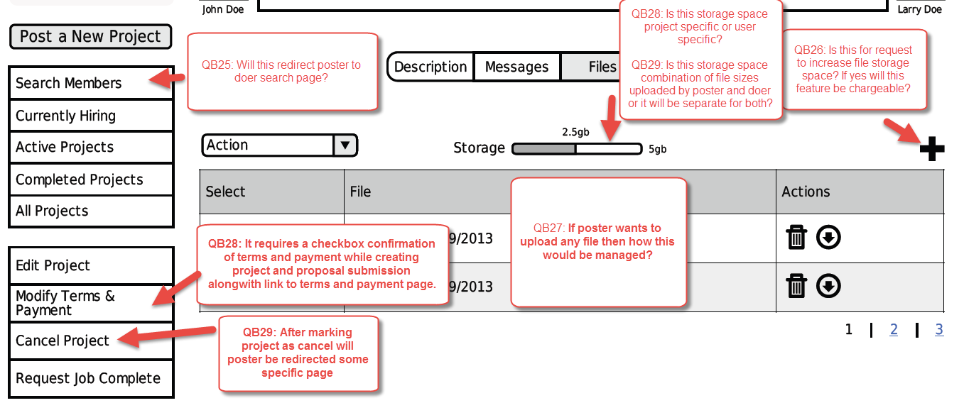

**QB25:** Yes, this takes you the Search for Members page.

**QB26:** The PLUS sign is for adding more files/attachments.

**QB27:** The user will upload more files by clicking the PLUS sign in the right hand corner. This action will open a pop-up/lightbox that allows the user to upload another file. The file will then be added to the list on this page.

*\*\*\*Queries QB28 and QB29 are listed two times. I have labeled them #1 and #2*

**QB28#1** *(Upper Right hand corner)*: The Storage Space is specific to each project, not user. The amount of storage space allowed should be a selection on the admin panel. The default amount should be 100mb per project, but that number could change (it probably will change) as our business grows, so make it something that I can adjust whenever I need to at the admin panel on the back-end. Also as part of the back-end – we need to be able to see the amount of capacity we have remaining for storage as a whole, so I will know if I have the capacity to increase the amount.

**QB29#1** *(Upper Right hand corner)*: The storage space will be a combination of files uploaded by the poster and the doer. It is the total amount of storage consumed for this project. All of the space may be taken by the Doer or all of the space could be taken by the Poster – it doesn’t matter. All that matters is that the project holds that amount of storage.

 Virendra: Can any one of them (poster/doer) delete files? If yes then what if other wants to see or use those files or they are required while resolving disputes.

Brad: Poster can delete files they posted. Doer can delete files they have posted. Let’s keep it as simple as that.

**QB28#2** *(Lower Left hand corner)*: What is the question here? If the Poster chooses this option, a pop-up/lightbox will appear with the terms that were agreed to along with inputs for the Poster to propose changes. The Doer has to agree completely with the terms changes for the changes to go into effect.

Virendra: Who will create Terms & Conditions for the project and what would be the location to add that on wireframe?

Brad:  The terms and conditions are already created for a project that has been awarded. They are price, duration, percentage, etc. The lightbox that pops up will show the existing terms and have an input box for them to be edited.

Here is an example (a crude mock-up) of what it could look like:

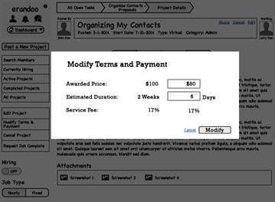

**QB29#2** *(Lower Left hand corner)*: When the project is cancelled, redirect the Poster to their dashboard page. The selection will require a confirmation warning – make sure the poster is asked, “Are you sure you want to cancel this project?”

Virendra: If doer has worked on it and payment is not made for that by the poster then what would happen?

Brad: Once a project is awarded to a DOER, that is a binding agreement between DOER and POSTER. Cancelling the project is not something that should be allowed lightly. It also should not become a complicated burden for the DOER.

If the project is cancelled after it has been awarded, it can only be cancelled with the DOERS consent. When the POSTER attempts to cancel a working project, the platform will send a system message to the DOER that tells them, “This project has been requested for cancellation.” A link in the system message in their inbox will create a pop-up/lightbox with three choices.

1.       Cancel the project

a.       This would cancel the project completely and no money is exchanged.

2.       Partial Completion

a.       This would trigger the cancelation page. The Doer will enter a percent complete and then enter expenses. It will work like completing the project, but without rating. I created a mock-up of wireframes for you to see the difference. See attached.

3.       Complete the Project

a.       The work is already done. If the Doer selects this option, they go to the complete project screen for this project. It is completed like any other project.

Matthew – does my mock-up do your wireframes justice? Is this the way you agree it should work?

--------------------------------------------------------------------------------------------------------------------

# Sterling API Process with users

As you know, our development team is working on integrating the APIs that connect our platform to yours. I know that our team is connected with your team for the technical aspects. The latest update I have from our development team is that the API is coming along fine.

I am interested in how we differentiate the three different sterling products we will offer. Our team is not sure what needs to happen to ‘order’ and ‘process’ the different levels of checks we will offer.

We have discussed the levels before, but as a refresher please allow me to summarize. We will have three levels of users:

•        Users who operate in the virtual space. We are going to do no background screening what-so-ever on any individual that is only going to work through the platform remotely.

•        The next level of user will have basic memberships – these are members who have signed up to use our platform and will be working in-person with other members. They will have a simple ‘safety check’ administered. This will be an enhanced Nationwide with Sex Offender Registry search. A very quick and inexpensive background check. Sterling will also manage the adverse action process for members who fail. On our end, the members will lose their account if they do not pass the safety check.

•        The third tier will be premium members – these members will join our website as premium members by paying a monthly subscription. As part of their subscription they will receive a higher quality background check including SSN trace and county searches. They will already been safety checked, they will need to add the SSN trace and the 7-year County searches. These members, as long as they maintain their subscription, will have a re-check of their ‘safety check ‘ quarterly and a re-check of their ‘premium check’ every six months. Sterling will also manage the adverse action process for members who fail the check or their re-check. On our end, the members will lose their account if they do not pass the premium background check.

***The third product from you that we will offer will be to allow a member of our platform to order a premium background check on any other member they are hiring for a task. Usually, this will only occur when a person posting a task has a favorite member they want to use, but that person is not already a paid subscriber. They want to see a real background – we will allow them the opportunity to purchase a background check for them. We need to understand how this connects and flows.

Our platform needs to understand the level of each user and are then communicate with your system which checks need to be accomplished. What I am seeking now are the details that need to come from our end to facilitate the correct level of checks, at the correct intervals; and how we receive the feedback to our platform to take action from the results.

I hope this all makes sense. I am available to have a conversation about this if there are questions; otherwise, my overall question: What details does your system need from our system (and when) so that the correct checks are triggered and the correct responses are received for each level/product?

Brad Nelson

====================================================================================

Here are my responses to the questions:

1. Previously you mentioned that you need IP block feature. Can you please elaborate it how exactly you want to manage IP blocking?

When a user/visitor is acting inappropriately, I would like to have the ability to close that person’s account; and if necessary, prevent anyone from the IP address they are using from accessing the website. If they have a specific IP (the IP of a troublemaker), I would like to block them from being able to make a new account.

a) What will be criteria to block IP?

IP will only be blocked by an admin for our business. It will be a conscious decision made by a human. It will not be automatic. I would like to have the ability to see the IP in the admin panel (the back-end) and then block any user who tries to create an account from that IP address.

b) Will admin block/restrict IPs from admin panel?

Yes. This should be something a leader in our team will do personally. From the back-end admin panel.

c) Will there be a feature to block IP by specifying range and individual IP?

Just individual IP. We likely won’t block an IP range because there will be good users within that range. But we need to ability for specific IPs to have no access to the site.

d) Will the whole site be restricted for blocked IPs?

Yes – because they have to be logged in to see anything other than the landing page. And if they have a blocked IP, their account will be disabled. They will have no access to login to the site.

2. Suspend User

a) Will admin suspend users manually or users will be suspended automatically if they do not follow certain rules or both?

It will be both. The criteria is not completed yet; but mostly, if you are a poor user with low rating, you will eventually have your account suspended. I will create the details this week.

b) If there is auto suspension then what will be rules?

I will send the details this week.

c) Suspended users will not be able to access whole site or part/feature of the site?

It will depend. They might only be able to access some training pages we will set up – for example, if a user is a poor Doer with a low rating, we might let them watch training videos to redeem their access. After they complete the training, their account will be un-suspended. But they will need access to their profile and the training videos, etc…

d) What are the sections for which users would not be able to access during suspension?

They won’t be able to post tasks. They won’t be able to bid on posted tasks.

e) What will be the suspension periods?

Until they complete some action, not for a set period of time. If they are suspended, they will stay suspended until they complete the action we decide for them.

f) If there is auto suspension can admin revoke suspension before the suspension time gets over?

Yes. Admin will have the discretion to re-instate (or remove) any poster’s permissions and access at any time.

g) Will admin specify suspension time each time in case of manual suspension?

Suspensions will be based upon some action to be completed, not likely for a set period of time.

h) Will there be different criterias of suspension for different type of users (basic, premium user)?

Yes, but they will be determined by what actions are required to re-gain access, not level of account. All users will be equal.

3. Category/Subcategory

a) Can poster change category or subcategory after posting the project but before anyone bids on it or they have to cancel project and create new like in case of project type?

Once a project is posted, they cannot change category and sub-category. They will have to cancel the project and start over.

4. Notification Settings

a) Will there be single save button or multiple save buttons for each kind of notification settings. Or each notification will be saved while check/uncheck its setting for email/sms?

There should be a save button for the notifications. The button should be on the left hand menu, like the action buttons for the other pages.

b) Is category/subcategory and skill related customized notification same or they are different from each other (like user can choose only skill of specific subcategory)?

The skills are not sub-category specific. If I have the skill of HTML, it is the same skill if I am in the ‘Web Design category’ or ‘teach computers’ category.

c) Can user select multiple subcategories for notification like skills?

Yes. Please.

5. Create Virtual Project

a) Will there be any fields to mention bid start/stop date?

Yes. There should be a field for when bidding will stop. Bidding starts as soon as the project is posted.

b) Will there be any field to mention project start date?

Yes. There should be a field for the date the project will start.

c) If we provide option to set default min-max price and estimated hours but user removes them and fills the fields with '0' then how this would be managed?

It will not be managed. We will let them make a foolish choice, and they will likely get poor responses. We will help them as much as we can with default values, but if they want to be foolish, we won’t manage them.

d) In case of of fixed price we find middle rate for price range by using average method (1000 - 5000 = $3000) and there is field for expected expenses (eg. $50) which might be one time expenses. We sum up these value (3000+50 = 3050) and display in estimated cost field which is not editable by the user. Is this correct?

Yes. This is a nice way to use that feature. It is just a guideline for the bidder – it is not binding.

In case of hourly rate there is one extra field 'estimated # of hours per week'. In this scenario expected expenses might be one time expenses then what will be flow to display estimated cost? It will be wrong if we include expected expenses for each week while some expenses might be only for one time (hosting expenses, domain expenses etc.)

It is only a guideline. It is not a binding agreement. If the estimated cost field is a good indicator, it is understood that it is not completely accurate. Especially since it is just an average from the range, with the estimated expenses in. It is just a guide. It is okay if it is just close and not perfect.

e) Can poster mention what expected expenses he might be expecting for expected expenses? If yes then we need place to enter that information.

Interesting question. I think we don’t make it so granular that it could become confusing. The amount is enough. For two reasons -- reason 1: If the poster is concerned, they can always put this information in their description. Reason 2: The poster might not have a clue and are hiring a freelancer than can help them figure it all out. Let’s not put so much detail that it becomes more difficult. An estimate of the expense cost is enough.

f) If user is not sure about project completion then how this will be managed?

They can leave it blank or make a best guess. This is not binding. The project is not going to ‘auto-close’ on them. the Doer still has to complete the project using the completion process, no matter what date it is.

g) If user is premium then will all projects posted by them be premium or only those tasks which are marked as 'premium' explicitly.

Only tasks that are marked as premium, will be premium tasks, no matter who posts them. Remember, premium task means that only premium members can bid for them. It costs money (there will be a charge that equals 16.75% of the final project cost) for a premium task.

h) When poster selects their previous task as template then which fields should be filled with old details?

All. Everything except the dates and any invited Doers. Description, title, pay, skills, attachments, questions, locations. All but the dates and people that were invited last time. Let them put new dates in.

i) In respect of projects display what is the difference between "Premium Posting" and "Highlighted Search Results" options.

Premium posting means that only a premium member can bid on this task. If you are a basic member and you try to post a bid on this project, you will instead get a roadblock advertising the benefits of the premium program.

Highlighted search results means that this task is the top of the search results and is highlighted with a different color (it needs to stand out). This is similar to a featured item on EBAY (or a pay-per-click featured result on Google). The purpose of this is for a poster to get very quick Reponses to a project that they think is important. They will be at the top of all of the search results and will stand out from the other search results.

I have attached the membership program. This will tell you the benefits of each membership level. I hope this is helpful.

6. Have you prepared profile, company, team related wireframes?

Profile and Company are not started in wireframe yet. The team pages are almost complete. Matthew is very close with the last version I saw – I expect to have that approved this week?

Rashmi, do we want to move on to the Profile for an individual and a company; or do we want to stick with the account creation process next.

I hope you found these answers useful! Please ask more questions if you need better answers! ☺

Brad

Here are my answers to your questions:

1. Create Task

a. Can poster modify estimated cost by overriding auto calculations based on price range, #of hours, expected expenses?

No. They cannot change the estimated cost by inputting in the box. They can change the outcome by adjusting what they enter for price range, # of hours, and expected expenses. But do not let them change the auto-calculations.

b. What information will be displayed to taskers in search results or other view pages for project cost (estimated cost or price range or both)?

I think just the price range in the search results.

2. User access

Can user search tasks without login? In this case for bid they have to login. Do we allow site access except landing page to logged in users to prevent spam users.

If they do not have a login, they only see landing page, FAQ pages, marketing pages, and terms pages. Marketing pages will be public facing pages that have features and benefits of our platform, maybe video presentations, to encourage people to sign up.

3. Notifications

1. From where user can set frequency of notifications to receive. (daily, weekly)?

Good question! You made me go back and study the wireframe to think this through. I don’t think any of our notifications need a daily/weekly filter. They are action oriented notifications, “If this happens, then send notification”. We don’t have any digest type notifications that need a frequency.

2. Will there be any limit on notifications for the user(# of posts from posted tasks)?

I don’t understand what you are asking. Which notifications and why would there be a limit?

Brad

3. Notifications

1. From where user can set frequency of notifications to receive. (daily, weekly)?

Good question! You made me go back and study the wireframe to think this through. I don’t think any of our notifications need a daily/weekly filter. They are action oriented notifications, “If this happens, then send notification”. We don’t have any digest type notifications that need a frequency.

I think if I user doesn't want to receive these notifications or wants to scale them (receive some via email or more urgent ones via SMS or push) then they have that control. Daily weekly filter would complicate push and SMS and would only be relevant to email for instance.

2. Will there be any limit on notifications for the user(# of posts from posted tasks)?

I don’t understand what you are asking. Which notifications and why would there be a limit?

I don't see a reason for a limit unless you're referring to the UI on the website where the notification icon is? In this case you woudl show probably the last 5 to 10 notifications and then a simple link the user can click to view all notifications. At that point they would be taken to the notifications page.

a) Will there be single save button or multiple save buttons for each kind of notification settings. Or each notification will be saved while check/uncheck its setting for email/sms?

We should follow the protocol for each of the setting screens. It's probably best as Brad said to simply have a save button since we will need it for the other sections. This keeps it consistent and easy to understand from a users standpoint.

a) Will there be any fields to mention bid start/stop date?

Yes. There should be a field for when bidding will stop. Bidding starts as soon as the project is posted.

Will a simple combo picker to choose how many days bidding last be appropriate here?

b) Will there be any field to mention project start date?

Yes. There should be a field for the date the project will start.

I see this on elance a lot but I find no one ever uses it or it's never adhered to. This would add an extra input. Do we think it's necessary? Most assume project starts soon after bidding ends and users can discuss exact start time that's convenient for both no? Just a thought.

e) Can poster mention what expected expenses he might be expecting for expected expenses? If yes then we need place to enter that information.

Interesting question. I think we don’t make it so granular that it could become confusing. The amount is enough. For two reasons -- reason 1: If the poster is concerned, they can always put this information in their description. Reason 2: The poster might not have a clue and are hiring a freelancer than can help them figure it all out. Let’s not put so much detail that it becomes more difficult. An estimate of the expense cost is enough.

Very good question and I think Brad is right on it here. If we go too granular with all of these posting becomes quite a task. People feel compelled to answer almost every field you put in front of them, so the fewer the better.

Matthew has a good point. I stand corrected. Let’s not use a field for the date the project will start.

It starts when the bidding is done. If there is any confusion/question – the poster and the doer and coordinate with the discussion messages.

No need for a field. Let’s keep it simple.

Brad

Hi.

You ask great questions as always. Please continue to ask as many as needed!

Answers:

Notification Settings

a. In doer section there is category -> subcategory and skill section for notifications.

How this will work? Will user first select Category then Subcategory and

These are filters for receiving the email or SMS notifications. The user can decide to receive a notification for All Categories, No Categories, a single category, or multiple categories. This will work as a drop down menu with multiple selections possible. The sub categories will work the exact same way. The sills will work similarly – the user will select which skills they want notifications for when a job is posted.

Here is an example: If I am a plumber, I want to set my notifications so I receive emails for all jobs that are posted in the Home Improvement Category, with ALL sub-categories in that category, and the skills for Pipe-fitting, fixture installation, and soldering.

-          OR – another example, maybe the same plumber want to see everything posted with pipe-fitting and fixture installation, no matter what category it is posted in. He has those skills and wants to have a Text Message sent to him every time a job with those skills is posted.

They are just filters. Instead of sending a notification for every project, we let the users add constraints so they only get notifications for exactly what they want to see.

create Virtual Task

"9.       What will be the search controls in invite task section? Can poster search invitees on country, skill or any other criteria? If yes what will be the flow and placement of controls.

Search based on Skills and location. Matthew will decide how the controls for this will work."

This is a conversation that Rashmi, Matthew and I are working on right now. Search control will be Latest time the user has been active, The number of projects that have been completed, Average price of projects completed, and location (county/city). The latest version of the wireframe is attached.

***NOTE: This version of the wireframe also shows the location for uploading files when creating a task. You will also create a section in the admin panel where we can limit the number of files to be uploaded and limit the file size of each file. The default setting for that admin control will be 4 uploads and 500kb per file.

Can poster close bid before the bid end date?

No. The poster cannot close the bid before the end date. The poster is the user who decided the end-date, so we will not let them close it. If there have been no bids, they can always edit the project, but once a Doer has made a bid, the project can no longer be edited and the bid closing date cannot be changed.

**On 23-06-2014 Brad said that poster can close the bid before the end date if they have found the relevant doers.**

3. Notifications

1". From where user can set frequency of notifications to receive. (daily, weekly)?

Virendra: Let me ask same question in other words. Suppose there is a user who has chosen 4 different subcategories and 10 skills for the notification alerts. Now, will that user receive the notifications instantly as separate emails/sms or will receive a consolidated email once a day or in every four hours whatever we decide to give options to user to choose from whenever a new project is posted matching his selection.

If there are 100 projects posted in his selected criteria for the notifications then he will receive 100 emails if we do not provide option to consolidated email.

Again, great question! Nice way to put it. I love the way your thinking is going. I understand what you are getting at – but the conversations I have had with Taskers and Freelancers is that they want to get the notifications right away; but they don’t want so many that they are useless. They need a detailed filter. So, we give them a powerful filter and send them the notifications in real time.

The answer is still one email/SMS per notification. If the person is receiving too many emails, they can adjust their filters to what they ‘really’ want to see. If they are not receiving enough notifications, they can broaden their filter criteria. To me, the point is this: What good is a notification, if I miss out on the good jobs that I really want because the notification email came 12 hours later or at the end of the week?

There may be different settings for the instant task because it has different model of the work.

Instant task will have zero notifications – for instant tasks, the Doer is logged in and ready for a task. Then they are selected by the Poster (or auto-assigned) and receives a push notification if they are selected. The push notification gives them the option to accept the task for the offer price, or decline the task.

Instant Task

a.       Template selection option for the project is missing in wireframe. Aren't we providing templates for instant task?

Instant Task is a special creature. The kind of project is so specialized that there will be very specific categories and sub-categories. There won’t be a need for templates. The goal is to make the categories and sub-categories so specialized that there will be no need to typing or reading for the poster and Doer.

Here is an example. If the task is to pick up my dry cleaning, the category will be Pick-Up. The sub category will be Dry Cleaning. The only thing the Doer really needs to know is my ticket number, the address where the clothes are, and the price. When we set up the website for public business, we will create such specific categories and sub-categories that there is no need for adding text (template or typed).

b.      What are the criterias to select a doer automatically?

Location. The user who is logged in as available (via their mobile device) who is also closest to the starting location for the task. The doer then receives a push notification if they would like to do this project, if yes, they are awarded the work. If no, the platform will send a push notification to the next closest Doer.

c.       Is there any concept of invitation in instant task?

The invitation will be a push notification sent to the selected Doer. The Doer must be logged in as available for Instant Projects; and the Doer must accept the instant project (chose yes or no on the push notification).

d.      Will doer be selected automatically or an invitation be sent while auto choice is selected?

A push notification will be sent when the user is auto-selected. They must accept the project, yes or no; otherwise, the project is then sent to the second users for acceptance, then the third, fourth, etc; until a Doer accepts the project.

e.       What does it mean by End Location on map?

Starting location is where the Doer will begin the project. End location is where they will complete it. As an example, a task to pick up dry cleaning would have the address of the dry cleaner. The end location would be the place where the dry cleaning is the be delivered (the project poster’s house maybe)?

If the task were a ‘reverse delivery’, for example, take my dry cleaning to the dry cleaners, the starting location would be my house, the end location would be the dry cleaner location.

f.       Is there any limit to display matching users on map?

No. The map should show all of the users who are logged-in as available nearby. If there are 100 Doers on the map, the Project poster can zoom in on the starting location to see less Doers.

g.      What are the matching criteria to display users on map?

This is a great question and it shows the heart of what makes an Instant Project. An Instant Project is instant because it is only shown to users who are ready for right immediately. The criteria for users on the map will be Doers who have selected ‘Available’ from their mobile device (this will be a choice on the main screen of the mobile wireframe). These Doers are logged in and waiting for an instant project to pop on their screen. If they are logged in as available on their mobile device, they are to be on the map. If they are not logged in as available on their mobile device, they are not to be shown on the map.

h.      If user manually selects doer then from where he can select the doer? How will it display on page?

The page on the web platform will show a ‘waiting’ icon (a spinning circle like you use when you are loading something. It will continue to spin until a Doer accepts the project. Once the Doer accepts the project, the platform will load to a ‘Live Project’ Page that shows the details of the task and shows who was assigned.

Project Complete Doer

a. Where is option to write review?

I would like the reviews/recommendations to be a separate function. It will be part of the dashboard and profile pages you will receive as wireframes in June. My goal is for the ratings to linked to specific tasks (like we have now) and the recommendations to be based on personal experience with the users (like the way LinkedIn does it).

Brad

Virendra: What will be the flow of selection? Poster posts a task -> Nearest user gets a notification. There may be following conditions.

 Will there be any default range to search doers. If yes then what? System will automatically check if any doer is available within this range and it will send push notification. In case there is no doer available then it will automatically increase the search range criteria and will check if any doer is available now. My question is will there be any max range boundry to search doer? If yes then how it will be calculated? Or it will be default fixed for each subcategory?

How the notification sending would work. Will system send no send notification to single nearest doer and waits for his response. If yes, then what if doer never responds back? We can use maximum time limit to get response (e.g. 5 minutes). If doer doesn't respond or sends negative response then system notification goes to next nearest doer and process repeats. But in this scenario it may take undetermined time to find proper doer for the instant task. To resolve we can send notifications to multiple doers within specified range. Whichever user responds first will get the job. Here my question is what will be the range? How it will be specified? By the doer at the time of instant task creation or it will be defined by the admin settings?

c.       Is there any concept of invitation in instant task?

The invitation will be a push notification sent to the selected Doer. The Doer must be logged in as available for Instant Projects; and the Doer must accept the instant project (chose yes or no on the push notification).

d.      Will doer be selected automatically or an invitation be sent while auto choice is selected?

A push notification will be sent when the user is auto-selected. They must accept the project, yes or no; otherwise, the project is then sent to the second users for acceptance, then the third, fourth, etc; until a Doer accepts the project.

Virendra: Please see (Instant Task (b.) query)

e.       What does it mean by End Location on map?

Starting location is where the Doer will begin the project. End location is where they will complete it. As an example, a task to pick up dry cleaning would have the address of the dry cleaner. The end location would be the place where the dry cleaning is the be delivered (the project poster’s house maybe)?

If the task were a ‘reverse delivery’, for example, take my dry cleaning to the dry cleaners, the starting location would be my house, the end location would be the dry cleaner location.

f.       Is there any limit to display matching users on map?

No. The map should show all of the users who are logged-in as available nearby. If there are 100 Doers on the map, the Project poster can zoom in on the starting location to see less Doers.

g.      What are the matching criteria to display users on map?

This is a great question and it shows the heart of what makes an Instant Project. An Instant Project is instant because it is only shown to users who are ready for right immediately. The criteria for users on the map will be Doers who have selected ‘Available’ from their mobile device (this will be a choice on the main screen of the mobile wireframe). These Doers are logged in and waiting for an instant project to pop on their screen. If they are logged in as available on their mobile device, they are to be on the map. If they are not logged in as available on their mobile device, they are not to be shown on the map.

h.      If user manually selects doer then from where he can select the doer? How will it display on page?

The page on the web platform will show a ‘waiting’ icon (a spinning circle like you use when you are loading something. It will continue to spin until a Doer accepts the project. Once the Doer accepts the project, the platform will load to a ‘Live Project’ Page that shows the details of the task and shows who was assigned.

Virendra: i. What is Home, Work, Red Hook, The City on map? Does these represents already saved locations? If yes how they will be managed and displyaed to poster?

j. What are the options available in Complete Task drop down for time selection?

Does this time starts from when the poster posts task or its the duration of the task within 48 hrs or whatever you decide?

k. Will there be any min - max project price range for instant task?

Notification Settings

a. In doer section there is category -> subcategory and skill section for notifications.

How this will work? Will user first select Category then Subcategory and

These are filters for receiving the email or SMS notifications. The user can decide to receive a notification for All Categories, No Categories, a single category, or multiple categories. This will work as a drop down menu with multiple selections possible. The sub categories will work the exact same way. The sills will work similarly – the user will select which skills they want notifications for when a job is posted.

Here is an example: If I am a plumber, I want to set my notifications so I receive emails for all jobs that are posted in the Home Improvement Category, with ALL sub-categories in that category, and the skills for Pipe-fitting, fixture installation, and soldering.

-          OR – another example, maybe the same plumber want to see everything posted with pipe-fitting and fixture installation, no matter what category it is posted in. He has those skills and wants to have a Text Message sent to him every time a job with those skills is posted.

They are just filters. Instead of sending a notification for every project, we let the users add constraints so they only get notifications for exactly what they want to see.

Hmm. I thought it was one main category and subcategory a user wanted to be a part of so I created the UI based on that. It may be that there isn't enough room with this setup unless we don't use a combo picker but a similar drop down with checkboxes beside each. A combo box would only allow for one thing to be selected at a time, where as a custom dropdown would allow for user to scroll and click a checkbox next to each category etc. A light box like on the advanced job posting view may be another option.

Can poster close bid before the bid end date?

No. The poster cannot close the bid before the end date. The poster is the user who decided the end-date, so we will not let them close it. If there have been no bids, they can always edit the project, but once a Doer has made a bid, the project can no longer be edited and the bid closing date cannot be changed.

Will there be a way for a user to file a dispute if things aren't working out or is it better that they just request a job be closed with the Doer?

c.       Is there any concept of invitation in instant task?

The invitation will be a push notification sent to the selected Doer. The Doer must be logged in as available for Instant Projects; and the Doer must accept the instant project (chose yes or no on the push notification).

With the push notification user would be taken to a card on mobile a project page on the website. This project page will be much simpler than the other project pages as there will be nothing much on it, it's simply for them to accept or decline a job and see any notes.

d.      Will doer be selected automatically or an invitation be sent while auto choice is selected?

A push notification will be sent when the user is auto-selected. They must accept the project, yes or no; otherwise, the project is then sent to the second users for acceptance, then the third, fourth, etc; until a Doer accepts the project.

Poster will not see automatic Doers selected. They will simply allow the system to invite a certain set number of relevant Doers if that many exist.

e.       What does it mean by End Location on map?

Starting location is where the Doer will begin the project. End location is where they will complete it. As an example, a task to pick up dry cleaning would have the address of the dry cleaner. The end location would be the place where the dry cleaning is the be delivered (the project poster’s house maybe)?

If the task were a ‘reverse delivery’, for example, take my dry cleaning to the dry cleaners, the starting location would be my house, the end location would be the dry cleaner location.

Some users won't have an end location so the UI is setup to just have a start location to begin with. If they need an end location they press that button and get another line just like the Start location and can enter that info. It may be that we discover people have multiple locations they want to enter, to begin with I only had start/finish for simplicity.

h.      If user manually selects doer then from where he can select the doer? How will it display on page?

The page on the web platform will show a ‘waiting’ icon (a spinning circle like you use when you are loading something. It will continue to spin until a Doer accepts the project. Once the Doer accepts the project, the platform will load to a ‘Live Project’ Page that shows the details of the task and shows who was assigned.

Yea, just a simple Waiting notification on the user. Could be that this displays on the button. Same for decline, just show decline on there. That button can have live status.

Answers:

Virendra: What will be the flow of selection? Poster posts a task -> Nearest user gets a notification. There may be following conditions.

 Will there be any default range to search doers. If yes then what?

•         Make the default Range 2 miles. Better yet – is it possible to give a control on the admin panel so the default range can be changed as needed?

System will automatically check if any doer is available within this range and it will send push notification. In case there is no doer available then it will automatically increase the search range criteria and will check if any doer is available now. My question is will there be any max range boundary to search doer? If yes then how it will be calculated? Or it will be default fixed for each subcategory?

•         Great Question! Ideally, the max range would be different based on geographic market. 1 mile in a very urban area would be too wide, but 10 miles in a city that is very spread would be too narrow.

•         I like where you are going with the sub-category. Can you make it so the default and max range for each instant task is an input in the admin panel for each sub category? For the default, make it 2 miles is default, max is 10 miles. Make it so that each can be adjusted by sub-category of instant task. Great thinking!

How the notification sending would work. Will system send no send notification to single nearest doer and waits for his response. If yes, then what if doer never responds back?

•         Let’s use a input in the admin panel to control this. Again, this should be by subcategory, but the amount of time should be 45 seconds. If no response in 1 minute, the system sends to the next Doer.

We can use maximum time limit to get response (e.g. 5 minutes). If doer doesn't respond or sends negative response then system notification goes to next nearest doer and process repeats. But in this scenario it may take undetermined time to find proper doer for the instant task. To resolve we can send notifications to multiple doers within specified range. Whichever user responds first will get the job.

•         I want to be careful with this. I would rather send a shorter duration than multiple Doers. The Doer is logged in – they are expecting to get work. They have chosen to be logged in. There should not be a lag time for accepting. These aren’t standard users, these are users who are looking for instant work. They are supposed to be ready.

Here my question is what will be the range? How it will be specified? By the doer at the time of instant task creation or it will be defined by the admin settings?

•         One Doer at a time. But the time will be short. The default will be 45 seconds to wait.

Brad

Updates below in RED:

Notification Settings

a. In doer section there is category -> subcategory and skill section for notifications.

How this will work? Will user first select Category then Subcategory and

These are filters for receiving the email or SMS notifications. The user can decide to receive a notification for All Categories, No Categories, a single category, or multiple categories. This will work as a drop down menu with multiple selections possible. The sub categories will work the exact same way. The sills will work similarly – the user will select which skills they want notifications for when a job is posted.

Here is an example: If I am a plumber, I want to set my notifications so I receive emails for all jobs that are posted in the Home Improvement Category, with ALL sub-categories in that category, and the skills for Pipe-fitting, fixture installation, and soldering.

-          OR – another example, maybe the same plumber want to see everything posted with pipe-fitting and fixture installation, no matter what category it is posted in. He has those skills and wants to have a Text Message sent to him every time a job with those skills is posted.

They are just filters. Instead of sending a notification for every project, we let the users add constraints so they only get notifications for exactly what they want to see.

Hmm. I thought it was one main category and subcategory a user wanted to be a part of so I created the UI based on that. It may be that there isn't enough room with this setup unless we don't use a combo picker but a similar drop down with checkboxes beside each. A combo box would only allow for one thing to be selected at a time, where as a custom dropdown would allow for user to scroll and click a checkbox next to each category etc. A light box like on the advanced job posting view may be another option.

•         It should look the way it does now, but the ability to choose multiple categories and sub-sub-categories will be important. Let the user decide how much or how few notification traffic they receive.

Can poster close bid before the bid end date?

No. The poster cannot close the bid before the end date. The poster is the user who decided the end-date, so we will not let them close it. If there have been no bids, they can always edit the project, but once a Doer has made a bid, the project can no longer be edited and the bid closing date cannot be changed.

Will there be a way for a user to file a dispute if things aren't working out or is it better that they just request a job be closed with the Doer?

•         If things aren’t working out, they will use the dispute resolutions process.

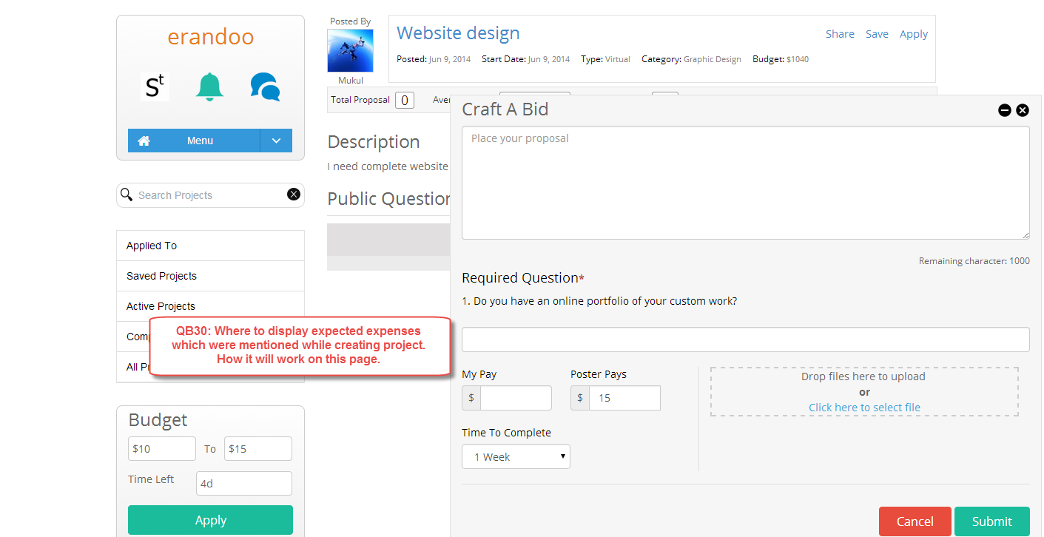

**QB30:** The expected expenses are something that the POSTER adds when they create the project. The DOER would not need to enter any expected expenses, but they should be required to acknowledge that his project has expected expenses. The acknowledgment confirms that they are prepared to pay the expenses and will expect to be reimbursed at the completion of the project. The expenses should show on the bid, but they should be in a box that cannot be edited. A required check box with disclaimer text should be there to give the Doer a place to acknowledge the expenses.

Here is a mock-up:

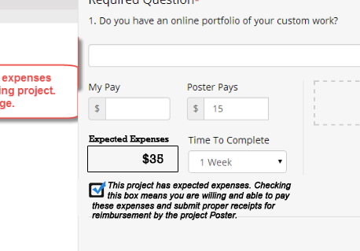

Please use that space underneath the bid price. Feel free to adjust my mock-up design to make it fit however you see it working the best.

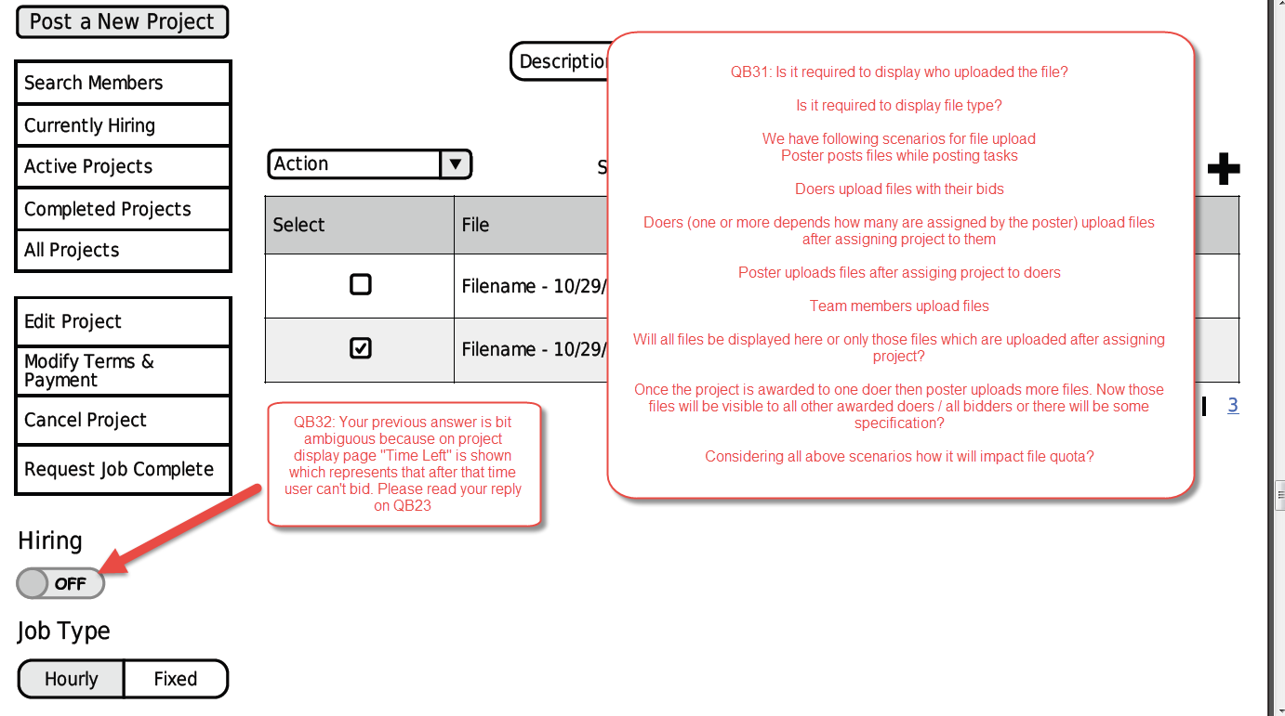

**QB31:** Answers about file uploads:

•         It is not required to display the name of the person who uploaded the file.

•         The file type should be part of the file name. “Sample File.docx”

•         Only the Team Leader will communicate with the client via messages, but any member of the team on an awarded project can upload files.

•         Any files uploaded to this project will be visible to the Poster and the Doer – if there are multiple doers, then consider that like multiple projects. The Poster and each Doer will interact independently, no matter how many Doers the poster has awarded this project to.

o   Imagine I award a project to a Doer named Joe. The project I am doing with Joe is number 1001. Then, I keep the project open and I award the project again, this time to a Doer named Larry. That is project 1002. Even though they are the exact same project posting, they are separate projects as far as Joe and Larry are concerned.

▪  Joe will only see files I upload and he uploads.

▪  Larry will only see files that I upload and he uploads.

▪  Joe will not see files I upload to Larry’s project.

▪  Larry will not see the files I upload to Joe’s project.

o   Both projects will have a separate space allocation quota for file uploading.

**QB32:** The project will remain open for more bids and more awarding, until the time is expired. As long as the time window is still open, I can continue to hire, even if I have awarded the project once, or twice, or more times. What this toggle does is let me keep hiring if I want more than 1 person.

If I find my Doer (or Doers) that satisfy me, if I close the hiring (toggle this option to “off”), bidding is closed, no matter how long I have left. If I open bidding for 3 days and find what I need in 1 day, I can close it and get to work.

Once turned “off”, bidding and awarding is off. No more search results, no more bidding. If the hiring toggle is turned “on”, the hiring will stay open until the time elapses or I turn the toggle to “off”. I can hire one or a hundred if I have this toggle on.

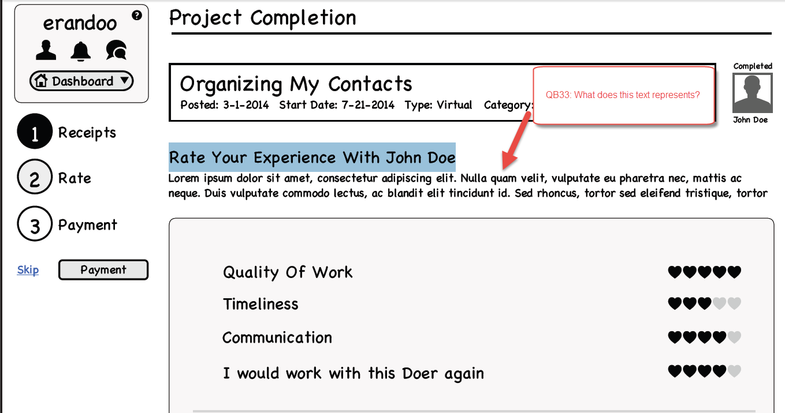

**QB33:** This text is a message to the Posters and Doers about how important a proper rating is.

****I will have copy for you to add later today. I will send it in a separate email.

**QB33:** As promised, here are the words to use on the Ratings. Here we have text to replace the lorem ipsum AND text that should hover over each category in the rating.

~~~~~~~~~~~~~~~~~~~~~~~~~~~~~~~~~~~~

For a POSTER who is rating a Doer

Text: “What did you think of your Doer? Your feedback helps Doers improve and recognizes Doers who are great at what they do. Feedback is broken down by category, so if you think your Doer excelled in most areas, but could improve in others, you can rate accordingly. Most importantly, be honest.”

…AND…

Hover this helpful text over each category:

•         Quality of Work

o   *Text Hover:* **Did they do a great job?**

•         Timeliness

o   *Text Hover:* **Did they complete the project on-time? **Delays that were out of the Doer’s control shouldn’t be taken into account.**

•         Communication

o   *Text Hover:* **Did you feel like there was an open line of communication throughout the project?**

•         I would work with this Doer again

o   *Text Hover:* **If you had another project that matches the Doer’s skillset, would you hire them again?**

~~~~~~~~~~~~~~~~~~~~~~~~~~~~~~~~~~~~

For a DOER who is rating a Poster

Text: “What did you think of the Poster? Your feedback is really important because it helps other Doers determine whether they want to work with this Poster. It can also help the Poster recognize things that they need to do better next time. Feedback is broken down by category, so if you think the Poster excelled in certain areas, but could improve in others, you can rate accordingly. Most importantly, be honest.”

…AND…

Hover this helpful text over each category:

•         Payment

o   *Text Hover:* **Was the payment fair for the amount of work the project required?**

•         Support

o   *Text Hover:* **Did they offer you the information and/or the direction you needed to successfully complete the project.**

•         Communication

o   *Text Hover:* **Did you feel like there was an open line of communication throughout the project?**

•         I would work with this Poster again

o   *Text Hover:* **If the Poster wanted to hire you for another project, would you work for them again?**

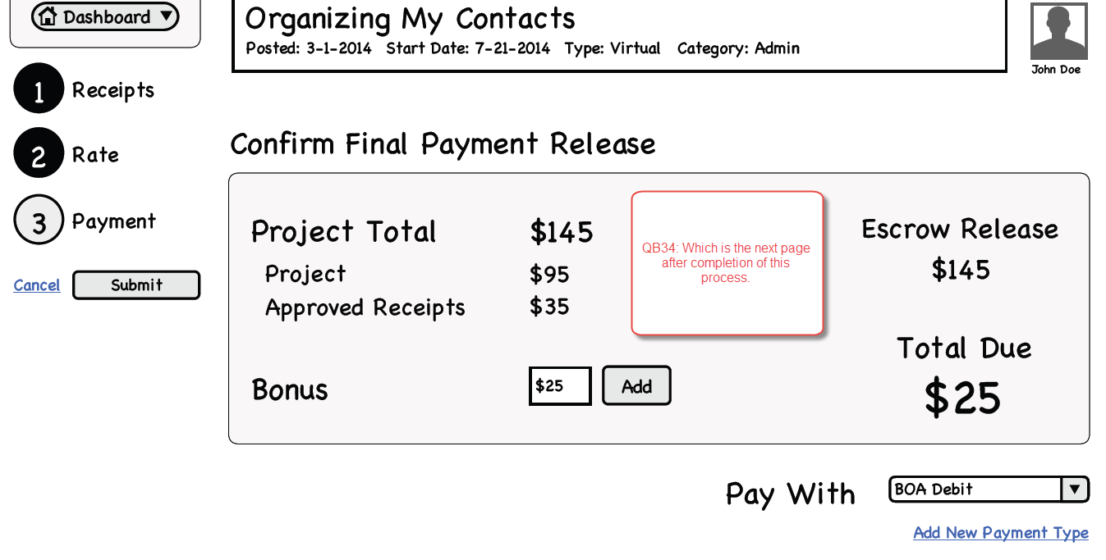

**QB34:** Once the POSTER completes the payment, take them to their dashboard. There should be a green colored system message at the top of the page (when they get to the dashboard) telling them, “Thank you for releasing the funds for your Doer. Your Payment was successful and your Doer should receive their payment directly to their personal account within the next day or two.”  Put an x in the corner of the system message so it can be closed out once it has been read.

Example of system message:

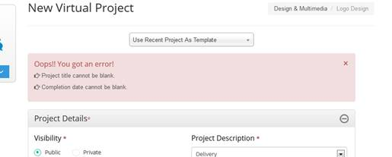

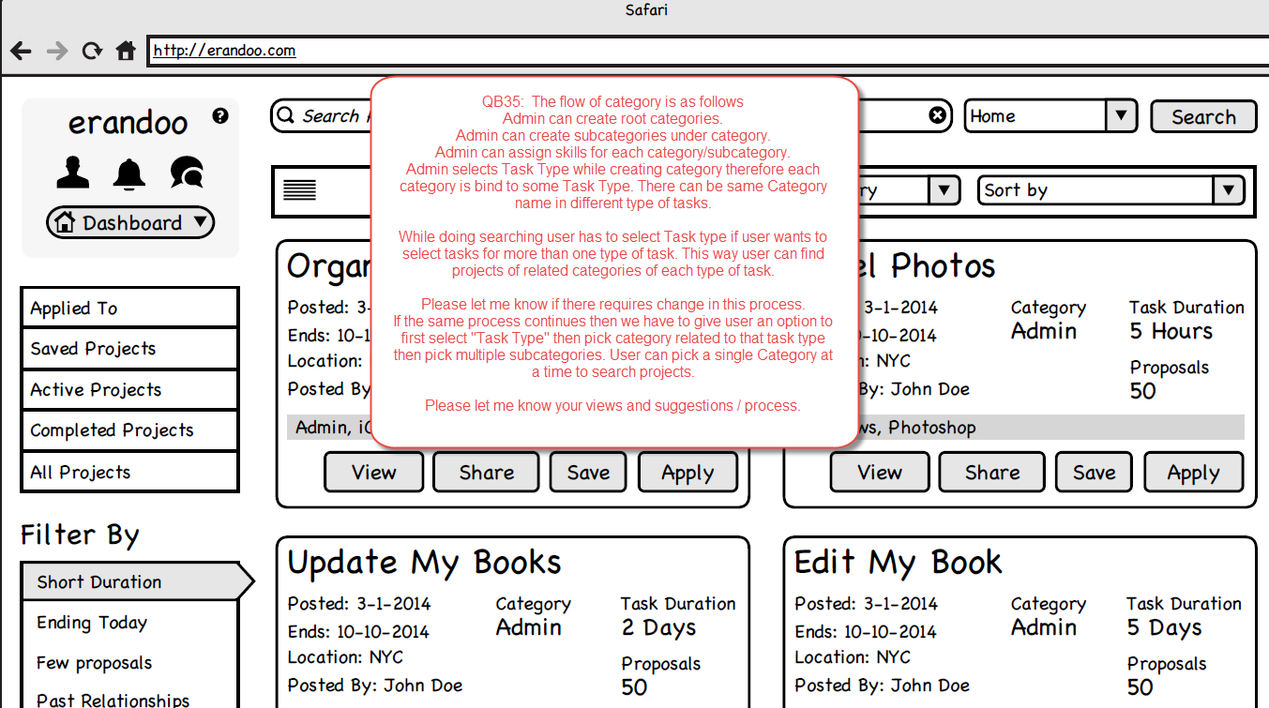

**QB35:** Great question. This will be a long answer – the answer will be at the end, but first some background that will help you with the answer. This is something that Matthew, Rashmi, and I were just discussing and had just worked through this week. Some of this will apply to the account creation process that we will be working on soon, but it does make questions that you need answers for now. This will help you when we start making the account creation.

Members of the platform will have the ability to use the site in four ways – they may be a Virtual DOER, an In-Person DOER, a Premium DOER; or as a POSTER. We call these four different versions their “License”. A user will need a “license” to do anything on the platform. Users can have more than one “license” at the same time. A user gets more “licenses” by signing up for more activities -- but everyone starts out with just one “license” based on how they began their account on our platform. Everyone starts somewhere. Some users will have more than one “license” -- they might be a POSTER and a Virtual DOER, or maybe they are a Virtual and In-Person DOER. Some Users will have all of the “licenses”. To gain any “license”, including their first “license”, a member has to complete the pre-requisites for that “license”.

•         To be qualified to be a **Virtual DOER**,  the user has to watch the Virtual DOER Orientation. A virtual Doer will only be served Virtual Projects in their search results.

•         To be qualified to be an **In-Person DOER**,  the user has to watch the In-Person DOER Orientation, passed the background quiz screen and the Safety Check; AND their location has to be in a zip code served by the platform. In-Person DOERs are ‘licensed’ to be a DOER for In-person AND Instant Projects – if a person has in-person, they also have Instant. An In-person DOER will only be served In-person Projects in their search results (remember, there are no Instant Project Search results).

•         To be qualified as a **Premium Member** is a bit more complicated, but is easy to understand. *\*\*\*NOTE: It might seem very complex for you and I, but to the web user, this will be invisible – they won’t know about all of these rules – they will just know what options they have in front of them. That is the beauty!*A Premium Member can be either Virtual or In-Person.

If the user is a Premium Member who only does Virtual Projects (by choice or because they do not live in a zip code that is served by the platform for In-Person):

•         Required to have watched the Virtual Orientation

•         Premium Subscription must be paid current.

If they are a In-Person Premium Member, the user has to have:

•         Passed the Background Check Quiz, Safety Check, and Premium Background Check

•         Their location must be in a zip code that is served by the platform

•         They have viewed the In-Person Orientation Video;

•         Their premium subscription is paid current.

•         To be a **POSTER**, the member has to have a verified funding source set-up on their account (Bank, Credit Card, paypal, Venmo); AND they have watched the POSTER orientation video.

The “licenses” give us power to serve each user only what they are prepared to receive. It lets us give them an easy way to decide how to interact with the platform. The license prevents overloading them with results they don’t want; and it helps us control their user experience by making sure they know what to do with the information they choose to see (the short orientation videos).

So, the answer to your question – 1). Do you need to change your process – no. It is good. 2). How does a member of the platform decide what search results they are going to receive? We do this on the Dashboard – the same place the user will change their location and their persona. Matthew will create wireframes for the dashboard that make it very simple for a user to toggle which licenses they want to work with today. They can look at only In-person, or In-person and Virtual, or all – if they have the licenses. Instead of selecting a “task-Type” in their search query, the user will instead activate their license that they are working with. They can turn on all of their licenses or just one of their licenses. The user will have control – and then the platform will serve them based on their selection.

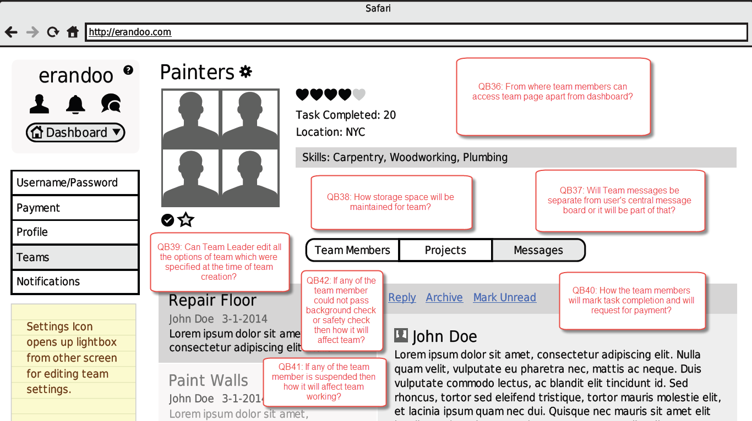

**QB36:** Team members come to the team page from their dashboard. If they want to go to the team page, they go to the dashboard.

 Users can access this from the Dashboard Quick Dropdown. That dropdown should include Teams, Members Search (also called Doers), Projects (search), and Settings.

**QB37:** Team messages will be in the users message central and on the team pages. We will have it in both places so it is easy and simple to communicate.

**QB38:** Teams will need a file attachment screen. A team file tab that is the same as the project file tab. The file storage quota will work exactly the same – a control on the admin panel will allow changing the amount of space allocated. The default will be 100mb.

**QB39:** The Team Leader can edit anything until a member joins. Once there is one member or more, the team cannot be edited.

**QB40:** The team leader marks the entire project complete. When the entire project is complete, all team members are paid their agreed upon percentage.

**QB41:** If a team member has a suspended account, their membership on the team is suspended as well. If the team member returns from a suspension, their position on the team is reinstated. If there is an active project for the team during the period that the member’s account is suspended, the team leader will be notified that this person will not be able to continue. The team leader will have the responsibility of communicating with the client and making a plan to replace that person’s role on the team. The suspended member’s agreed percentage is evenly distributed among the remaining team members until a replacement is added to the team with a negotiated percentage.

**QB42:** Any member that cannot pass a background check is removed from the platform immediately. Their account is closed. The Team Leader will be notified that this user is no longer a member of the platform. The team leader will have the responsibility of communicating with the client and making a plan to replace that person’s role on the team. The removed member’s agreed percentage is evenly distributed among the remaining team members until a replacement is added to the team with a negotiated percentage.

**Message Central:** Message central is an inbox. It works like an inbox, except, each message and reply functions like a discussion forum instead of an email. This will make communication very simple.

Every project will have a single message central thread. The project thread between the poster and the Doer will be shown in the Message Central Inbox and the messages tab on the project – this will ensure that communication is easy to find and easy to see. When a project is completed (funds released, done) the message thread in the message central is automatically archived.

Every team will also have a thread per project. That means a project with a team will have two message threads – one between the poster and the team leader, and another between the team members so they can collaborate. The project thread with the team leader will be visible on the project page. The project thread with the team members will not be visible in the project thread, but will be visible in the team page. When the project is complete, the thread is automatically archived from the message inbox.

Image attachments that are posted in the threads should post to the  message and automatically resize – the idea is that I can post project photos and they appear in the thread, not as attachments. They should resize so they are easy to see in the thread without making horizontal scrolling.

 =================================================================================

Option to set search range by doer is missing from wireframe. Can Poster set/change these option as per their requirements. Will the system override default settings if applicable in case no doer is found using those settings?

Ans: Here's my take. I didn't inlude that as I felt it should work like Uber, Lyft, or Google/Apple Maps.

The search range is first determined by whatever we set as the default on the system (ie 5 miles), but if a user wants to search more they can expand the map (zoom out) and see more results. At this point it's up to the Member requesting an instant task to determine how far they're willing to expand their search.

On the flip side of the coin, it's up to the Doer to determine if the task at hand is something they can accomplish due to location and time constraints. I think the parties involved here are the 'intelligence'.

Just my 2 cents of what we can do without adding another input. The map is already there ready to go.

=============================================================================================

**QB43:**

•         The person icon on the left corner should be eliminated. It has no purpose.

•         The question mark on the right corner will have no hover-menu choices. Instead, clicking this link will darken the while screen (like a light box) and a description (ALT Text description) of every link/feature on that particular page will overlay the screen. The overlay will also have a graphic link to the FAQ and will have IM chat access to the concierge team. The question mark will be one-click help for every question a user might have on each screen. This will be a very powerful feature that will give us a great advantage.

•         The arrow icon on the left should be replaced with the person silhouette icon. The arrow is the wrong graphic for this place. I understand why it is there, it was a choice on a wireframe, but that wireframe has been updated.  This should be the Person silhouette. When clicked, a hover menu to change Location, Persona, and License will pop-up. Persona and Location might be changed with a drop down. The ability to toggle multiple licenses will be necessary.

Here is a suggested mock-up of how this hover menu should function (in my mock-up, Virtual/In-person/Premium licenses are toggled – Project Poster is not:

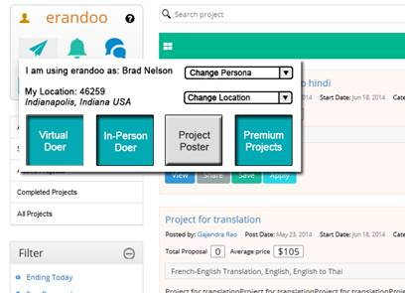

•         The menu bar should have no drop down hover pop-up. It should be nothing more than an immediate link to the Dashboard. The button should have a icon of Home and should be labeled Dashboard. It is meant to be a fast, easy way for a user to get immediately to their dashboard from anywhere in the platform.

•         The Small downward pointing arrow next to the Dashboard button should make a hover menu when clicked, just like you have it working right now. It works great now, just the way it is. Your menu choices are almost perfect. The wording of the menu choices on this hover menu should be changed just a little:

|  |
| --- |
| Dashboard |
| Create New Project |
| Search Projects |
| Search Members |
| My Teams |
| Message Central |
| Account Settings |
| Notification Settings |

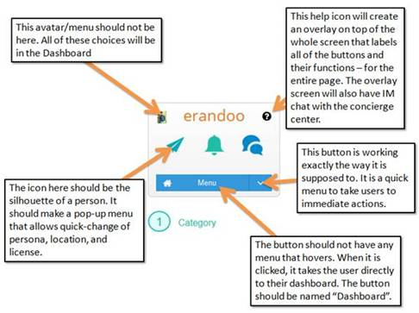

**QB44:** Poster can only invite Doers who have the license to do the kind of project they are posting. A Virtual Doer cannot be invited to do an In-person Project. Only doers who have the correct license should be served up in the search results.

It will be the responsibility of the Poster to message his favorite Virtual Doer and ask them to add In-person to their licenses if they want to be considered for a new project they are going to post. (or premium, etc)…

**QB45:** the two types templates do not do the same thing. The re-use templates at the very top allows the poster to re-do a project they have previously listed. It is will populate the dollars, the skills, etc – all the same as before.

The project templates instead gives the choice for changing the text description. This is useful for someone who does not know what to write 9maybe not a creative person).

If clicking one choice overwrites the other, the poster can just click the other choice again to overwrite again. I can imagine scenarios where the poster might click over it on purpose, to see which they like better – or they might click the Re-use template first, then click the project template to change the description, but leaving the other fields already populated like last time (the price, the skills, etc).

They should stay in two different locations, just like you have them.

======================================================================================================

Good morning!

First, These are great questions. This is a very complicated complex feature. These questions will help us make sure w get them all perfect!

Answers:

What if team leader doesn't continue the running project or abandon the system?

Great questions. It could be complicated. The simple answer is: The Team leader CANNOT leave the team if there is an active project. We do not allow them to leave the team. If they are leaving the team, then most of the time they are also going to be leaving the platform. If they leave the team, they are abandoning the obligation they agreed to for the poster and their team mates. We will not let them do that without also suspending their account permanently. **There are only a very few number of exceptions (military service, hospitalized, etc).**

The logic rules:

•         If the Team Leader leaves when there is no active project, the team is dissolved. They do not need any exceptions or permissions to leave the team if there is no active project.

•         If the team leader leaves the team during an active project, the user who has been on the team the most amount of time becomes the Team Leader. The new team leader will be responsible for communicating with the client, completing the project, and inviting any replacement members.  Once the project is complete, the team is automatically dissolved after funds are released. (***NOTE: if the team members liked working together, they need to create a new team together).

•         If the team leader leaves the platform involuntarily, meaning that their account has been cancelled and they will no longer be a member of the platform, they will still get paid the complete agreed upon percentage -- unless a formal dispute resolution is filed. (i.e. they didn’t do any work at all).

•         If the team leader leaves the team voluntarily, well, **they can’t**… ☺ They can quit the platform and never return, or they can ask for an exception from the dispute resolution team. If they qualify for an exception – an absence that they can prove (they are called away for military service, hospitalization, or bereavement), the dispute resolution team can allow them to leave without suspending their account. The next person on the team with the most longevity will become the team leader. When a team leader leaves the project voluntarily, they are not paid for their percentage unless the dispute resolution team approves.

What would happen with project and payment to team members?

•         If the team leader leaves the team while it is an active project, the project continues with the team member with the longest tenure on the team becoming the team leader. My goal is to protect the POSTER – I am not concerned about what happens to the team. I want the Poster to be able to have their project completed without a disruption.

•         The team members will still be expected to carry-on with the project and should still expect to be paid their percentage.

o   If the new Team Leader needs to invite a replacement for the skills that were lost, that payment will come from the percentage the old team leader was to receive.

▪  If the old team leader left involuntarily (expecting to be paid for work completed) the new Team Leader needs to initiate a dispute resolution about the work that was not completed. The new team leader will invite a Doer to complete the unfinished work and will negotiate a percentage with them.

Will the payment for the project be paid on completion of project/weekly/monthly or there would be any other order?

•         If it is an hourly project, the project will be paid at the weekly invoice period, just like an individual Doer.

•         If the project is a fixed price, all team members will be paid at the completion of the project.

If there are 3 members in a team. They are working on one project but one member's work depends on the completion of work of other doer. First member has completed his part of job now second doer start to work on it which may take 3-4 months for completion.

If payment is made at the end of the project completion to everyone then first doer has to wait for project end for final release of amount or first doer can get it before project completion as he has completed his part of job.

•         Yes. The first Doer will have to wait. All team members get paid at the same time. A three month project should probably be an hourly task project, not a fixed price project. That would mean that all team members get paid their percentage every week.

If team leader doesn't respond to client then how it would be handled?

•         If team leader does not respond to the client, it will be handled just like any other Doer who does not respond to a Poster. The team leader is the only person who communicates with the client. If the client cannot make contact, they will escalate to the dispute resolution team If dispute resolution team cannot make contact, they will suspend the team leader; causing the next senior person to become the new team leader. The dispute resolution team will connect the Poster and the new Team Leader so work can continue.

If payment is made on each process completion then how it will be handled along with payments?

•         Payment is not made by process completion. Payment is paid either weekly (hourly task) or upon completion of the entire project.

Will the amount percentage be distributed as per their agreement? In this case second doer may abandon the work while he has already received partially percentage of money for the work done by the first doer.

•         That would be a case where the dispute resolution team would be involved. It is a very unfortunately scenario, but not one that can easily be prevented with platform rules alone. The team leaders need to choose team members they can trust. Team members only join teams where they trust the other members. The choice they have is join or not join – they should only be part of teams that they have confidence in their integrity.

Can only team leader communicate with client or its team members are also allowed to communicate with client?

•         Only the team leader communicates with the poster. The purpose is to make one point of contact for the Poster. The goal is to keep it as simple as possible for the Client.

What if project requires any other doer in team? How the payment distribution will be handled in this case because team leader has already distributed 100% share of project amount on which other members were agreed upon?

•         When this occurs, all team members will have to agree to the addition of another member and a change to their terms. Adding another Doer means the amount per Doer is diluted – each Doer has to agree to the new terms.

•         To make this easiest, there will never be any secret how much each doer is earning. The percentage will be known. When there is a change, all Doers will see the percent and agree to the percent of the others.

What if one team member doesn't deliver good work? Can team leader change the amount for that doer?

•         The team leader cannot change any amount for any Doer without the Doer also agreeing to the change in terms. The team leader is not their ‘boss’. They are all independent contractors. Both parties have to agree to the rate at the beginning and then also agree to any changes. The team leaders need to choose team members that they know will do good work. Team members only join teams where they know that the other members will do good work. The choice they have is join or not join – once they begin a project together, they are tied to each other’s performance.

Brad

============================================================================

Hi Brad,

I need further clarification on space quota management which we discussed yesterday.

Q. Quota will be project based or user based

Ans. If there are more than one doer assigned for one project then each pair of doer-poster will have 100MB disk space allocated.

When poster creates project and uploads attachments those attachment will take space on disk e.g. 50MB.

case1:

Project is not awarded to anyone therefore there is no relation between poster and doer till now. So considering this how the space quota will be managed?

case2:

Now lets assume 50 doers bid on this project.

My question here is how the space will be managed in this case? How much space will be allocated?

case3:

Poster has assigned the project to 5 doers then each pair of doer-poster will have 100MB space allocated. Total 500MB space is allocated. Poster has already uploaded 50MB of files before awarding project therefore 250MB space will be consumed for all 5 pairs because we are considering 50MB space for each pair. If poster deletes files uploaded by them then space would be freed up only for the pair from which file is deleted.

Is this okay or there is change in this?

Q. How the search locations would be managed in profile and used on search page. The option is mentioned on right side of search bar as dropdown containing values like Home, Office? What other options would be available here?

ANSWERS

***Note: All of the space allocations need to be an input field on the admin panel. This amount of space allocated will be subject to change at any time – it needs to be a control that I can change without re-coding.

Answers:

Project is not awarded to anyone therefore there is no relation between poster and doer till now. So considering this how the space quota will be managed?

•         If project is not awarded, the project attachments will be allocated against the posting.

•         The amount of the quota for a poster should be a control on the admin panel

o   The default amount should be 10MB for a Project Poster (for a project that has not been awarded).

Now lets assume 50 doers bid on this project.

My question here is how the space will be managed in this case? How much space will be allocated?

•         The amount of the quota for a bidder should be a control on the admin panel

o   The default amount should be 10MB for a Project a bidder (for a project that has not been awarded).

Poster has assigned the project to 5 doers then each pair of doer-poster will have 100MB space allocated. Total 500MB space is allocated. Poster has already uploaded 50MB of files before awarding project therefore 250MB space will be consumed for all 5 pairs because we are considering 50MB space for each pair. If poster deletes files uploaded by them then space would be freed up only for the pair from which file is deleted.

Is this okay or there is change in this?

•         Yes. Do it like this. Remember, the amount of space might change. It should just be an input on the admin panel.

How the search locations would be managed in profile and used on search page. The option is mentioned on right side of search bar as dropdown containing values like Home, Office? What other options would be available here?

•         Users will be able to set up several locations for themselves in the Dashboard. They will be able to name the location however they like and they will be able to have as many locations set as they choose. The user will be able to change the location on the hover-menu that is populated on the person silhouette icon on the erandoo action menu. They will also be able to set their ‘default’ location on their dashboard.